HUD LGBT EQUAL ACCESS RULE INFORMATION SHEET FOR HOUSING PROVIDERS
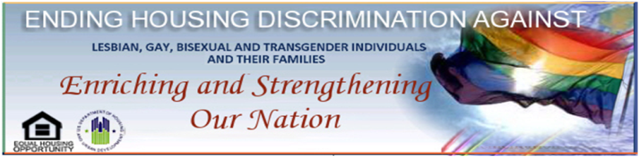

WHAT: The recently published final HUD rule “Equal Access to Housing in HUD Programs Regardless of Sexual Orientation or Gender Identity,” commonly referred to as the “Equal Access Rule,” is now effective. The final rule is available at the following link:

http://portal.hud.gov/hudportal/documents/huddoc?id=5359-F-02EqAccessFinalRule.pdf

WHEN: The final rule was published on February 3, 2012. The final rule became effective on March 3, 2012.

THE RULE:

· Requires entities assisted by HUD or insured by FHA to make housing available without regard to actual or perceived sexual orientation, gender identity, or marital status;

· Clarifies that the definition of “family” and “household,” which identifies who is eligible for HUD’s core programs, includes persons regardless of actual or perceived sexual orientation, gender identity, or marital status;

· Prohibits HUD-assisted and HUD-insured entities from inquiring about an applicant’s or occupant’s sexual orientation or gender identity for the purpose of determining eligibility or otherwise making housing available;

· Prohibits FHA-approved lenders from basing eligibility determinations for FHA-insured loans on actual or perceived sexual orientation or gender identity.

WHO: The definitions HUD utilized in the rule are based on the Office of Personnel Management’s definitions established for use in the federal workforce in its publication “Addressing Sexual Orientation in Federal Civilian Employment: A Guide to Employee Rights.” The definitions are as follows:

· Family has the meaning provided this term in § 5.403, and applies to all HUD
programs unless otherwise provided in the regulations for a specific HUD program.

· Gender identity means actual or perceived gender-related characteristics.

· Sexual orientation means homosexuality, heterosexuality, or bisexuality.

RESOURCES:

HUD Office of Fair Housing and Equal Opportunity has developed a website that is available here: http://www.hud.gov/lgbthousingdiscrimination. The website provides a link to the final rule, a link to a webinar explaining the final rule, examples of when and how the rule applies, information about state and local laws that include sexual orientation and/or gender identity as protected classes, and information about how an individual may file a complaint of housing discrimination or violation of the LGBT Rule. A Question and Answer Page will also be available on the website in the near future.

